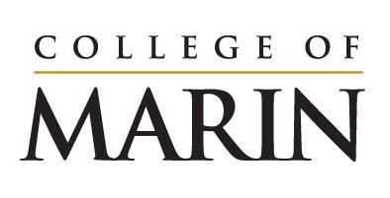
Notice of Construction Activity
July 10, 2023 – July 16, 2023

Please see below for construction activities happening on the site of the Learning Resources Center, July 10 – July 16.

- Grading to continue on site
- Continued installation of shoring wall which will include drilling holes, pouring concrete, installing steel
- Demolition of the old building foundation piers
- Drilling and excavation for foundation work
- Cement deep soil mixing

Noise you will expect to hear onsite:
- Large equipment such as drills/augers
- Idling trucks
- Back up alerts

Cement deep soil mixing continues this week. This process involves blending native soils with cement in order to stabilize the ground to obtain a better load bearing capability of the existing soil. This process involves first extracting soil from the ground with an auger then injecting cement into the excavated hole. As the cement-soil mix begins to harden, further cement is added on top of the growing column until the column reaches all the way up to the start. They will do this over and over again per the approved plans throughout the site. Once fully hardened these columns are then able to bear much higher loads than the native soil. This work will take them approximately seven more weeks.

If you have any questions please reach out to Klaus Christiansen at kchristiansen@marin.edu.

