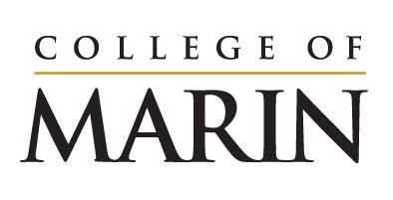
Notice of Construction Activity
July 17, 2023 – July 23, 2023

Please see below for construction activities happening on the site of the Learning Resources Center, July 17 – July 23.
- Grading to continue on site
- Continued installation of shoring wall which will include drilling holes, pouring concrete, installing steel
- Demolition of the old building foundation piers
- Drilling and excavation for foundation work
- Cement deep soil mixing

Noise you will expect to hear onsite:
- Large equipment such as drills/augers
- Idling trucks
- Back up alerts

If you have any questions please reach out to Klaus Christiansen at kchristiansen@marin.edu.

