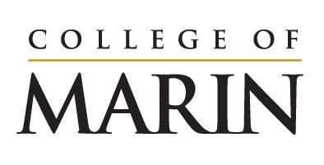
Notice of Construction Activity
August 14, 2023 – August 20, 2023

Please see below for construction activities happening on the site of the Learning Resources Center, August 14 – August 20.
- Grading to continue on site
- Continued installation of shoring wall which will include drilling holes, pouring concrete, installing steel
- Demolition of the old building foundation piers
- Drilling, grinding and excavation for foundation work
- Soil is being moved from the site to P15. This involves heavy truck traffic. Barricades and numerous flagmen will be used to assist pedestrian movement on campus.

Noise you will expect to hear onsite:
- Large equipment such as drills/augers
- Idling trucks
- Back up alerts

PLEASE NOTE: Pay close attention to directional signage and flagmen on campus. They are there to protect the safety of everyone on site.

If you have any questions please reach out to Klaus Christiansen at kchristiansen@marin.edu.

