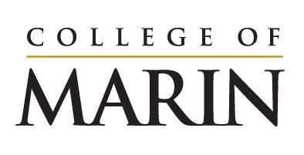
Notice of Construction Activity
August 21, 2023 – August 27, 2023

Please see below for construction activities happening on the site of the Learning Resources Center, August 21 – August 27.
- Grading to continue on site
- Continued installation of shoring wall which will include drilling holes, pouring concrete, installing steel
- Demolition of the old building foundation piers
- Drilling, grinding and excavation for foundation work
- Soil is being moved from the site to P15. This involves heavy truck traffic. Barricades and numerous flagmen will be used to assist pedestrian movement on campus.

Noise you will expect to hear onsite:
- Large equipment such as drills/augers
- Idling trucks
- Back up alerts

PLEASE NOTE: This is the first week of classes for the College which will mean increased activity on and around campus. Please pay close attention to directional signage and flagmen on campus. They are there to protect the safety of everyone on site.

If you have any questions please reach out to Klaus Christiansen at kchristiansen@marin.edu.

