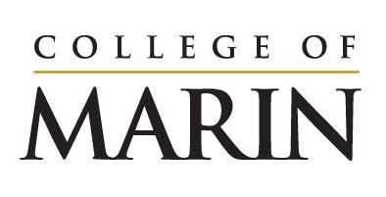
Notice of Construction Activity
November 13, 2023 – November 19, 2023

Please see below for construction activities happening on the site of the Learning Resources Center, November 13 – November 19.

- Rebar delivered and installed for the foundations
- Trenching for water line installation near AC
- Foundation concrete pour #1 (see note below)

Noise you will expect to hear onsite:
- Noisy steel work such as moving metal against metal and hammering metal
- Excavators and other typical construction equipment
- Crane operations including safety horn
- Idling trucks
- Back up alerts
- Diesel generators for site lighting

Please reach out to facilties@marin.edu directly with questions or concerns.

Please note: The first of the three large concrete pours for the building foundation is scheduled for Saturday, November 18th beginning at 3am. There will be diesel generators onsite powering the site lighting needed for the pour. In an effort to reduce the impact on the amount of traffic on College Avenue which would negatively affect the neighbors and businesses along that street, we are having the trucks que onsite. Lot 6 and a portion of Lot 9 will be shut down on Saturday to accommodate the cement trucks. They will be pouring 1,850 cubic yards (cy) and it will take approximately 12 to 15 hours (basis of pour length 215 cy/hr)

