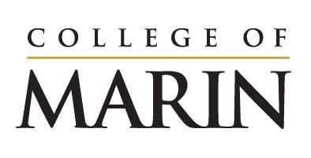
Notice of Construction Activity
December 11, 2023 – December 17, 2023

Please see below for construction activities happening on the site of the Learning Resources Center, December 11 – December 17.

- Rebar delivered and installed for the foundations
- Water line installation near AC
- Foundation concrete pour #3 (see note below)
- Lot 6 and a portion of Lot 9 are closed beginning Friday, December 15 at 6am

Noise you will expect to hear onsite:
- Noisy steel work such as moving metal against metal and hammering metal
- Typical construction equipment
- Crane operations including safety horn
- Idling trucks
- Back up alerts
- Diesel generators for site lighting

The LRC project team has successfully completed 2 out of the 3 large concrete pours for the foundation for the new building. There is one more remaining and it is the largest of the three to date.

This last pour will be over 2600 cubic yards of concrete. It will require a minimum of 80 trucks at any given time to be on the road bringing concrete to the site or returning to the plant to pick up another load.
With that many trucks on the road, and that much concrete to pour, speed and efficiency is critical. The construction team will be pouring this final portion of the foundation beginning Friday, December 15th at 9pm and working through the night to complete it in the late afternoon of Saturday, December 16th.
The following considerations have led to this schedule modification:
There is significantly less traffic on the roads, bridges, and freeways between the source location of the material and the site of the LRC which will allow for them to pour more material at a faster rate
- There is significantly less of an impact on the roads around the College since schools and many businesses are closed completely or for a vast majority of the pour time
- There is less impact on student programs/activities

The College has also taken steps to make sure all the trucks can que on campus so as not to more significantly impact College Avenue.

We understand that these pours will be impactful to our external community members. We appreciate your collaboration as we work through these necessary impacts.
If you have any questions, please reach out to facilities@marin.edu .

